Instructions for using eVitran / Budget Allocation Software

General requirements for running running eVitran / Budget Allocation software

- The application is best viewed In IE Explorer 5.0+ and 1024 X 768 Screen Resolution.
- For viewing reports you need Adobe PDF reader installed in your computer. You can install Adobe PDF Reader from the link provided ( ) on the web site on right bottom.
- Popup should be enabled in the Internet Explorer to view reports. To disable Popup blocker follow the instructions in the document How to disable popup blocker in Internet Explorer.pdf
- Applications Login section is only meant for HOD’s who have to login to the site with the provided User id (Which is the HOD code of the respective HOD) and password to allocate the budget to their DDO’s.
- Applications Second section is meant for DDO’s to view their sanction letters by entering Treasury Code and DDO code. Steps to view the sanction letter are described later in the document.

General View of the front page of application

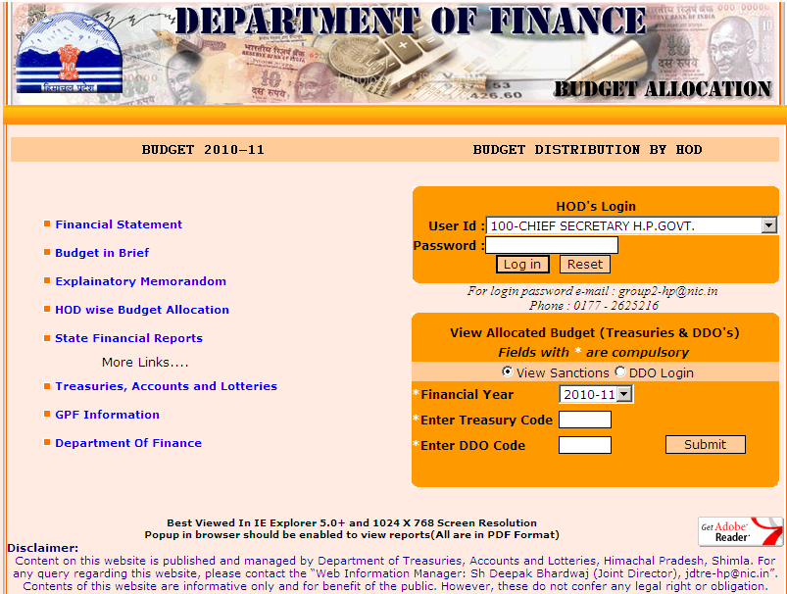
Login Area for HOD’s.
Only used by respective HODs to Allocate / Surrender & Sanction budget to their DDOs.
Step 1. Select your HOD from User Id list.
Step 2. Enter password and press Login button
This Section is For DDO’s.
They can view Sanction Letters of the budget allocated to them by their respective HODs.
Step 1. Enter Treasury Code
Step 2. Enter DDO Code
Step 3. Press Submit. Which will display the list of sanction Letters
Step 4. Select Letter Number.
Step 5 Click View Sanction Letter
Click here to download Adobe PDF Reader

Process to view Sanction Letter

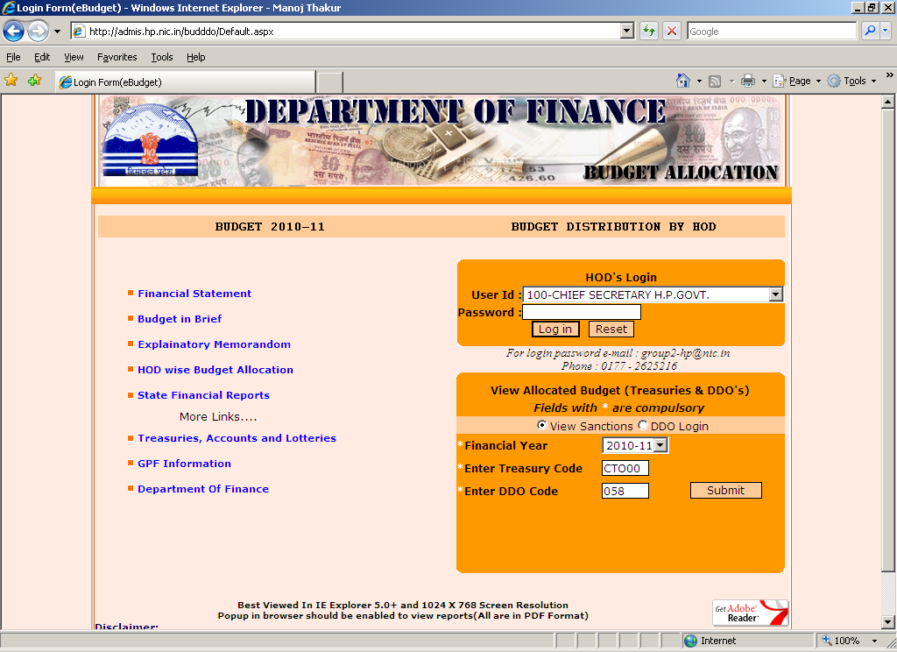
Enter Treasury Code.
Enter DDO Code.
Press Submit button.

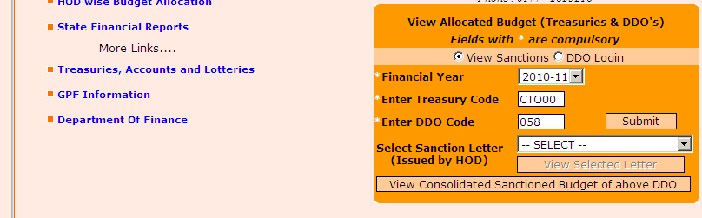
DDO section view after entering Treasury Code & DDO code and pressing Submit Button
Select Letter Number by clicking on the drop down list.

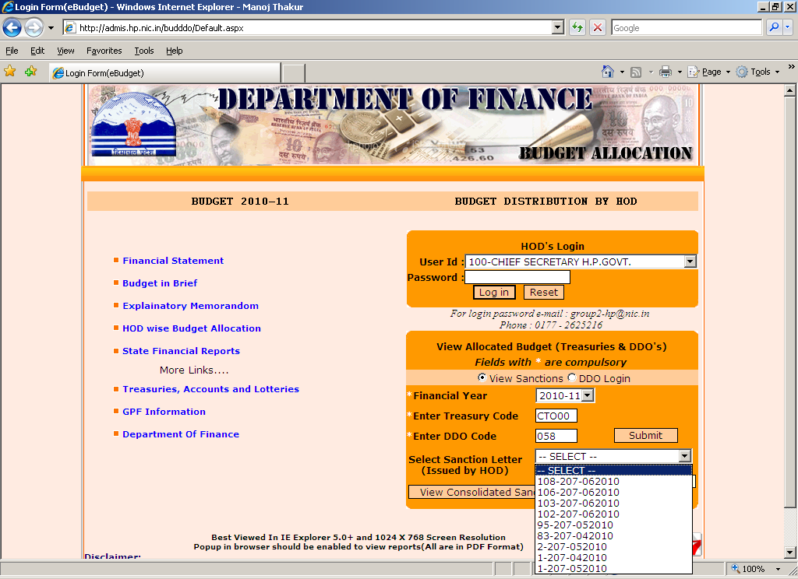

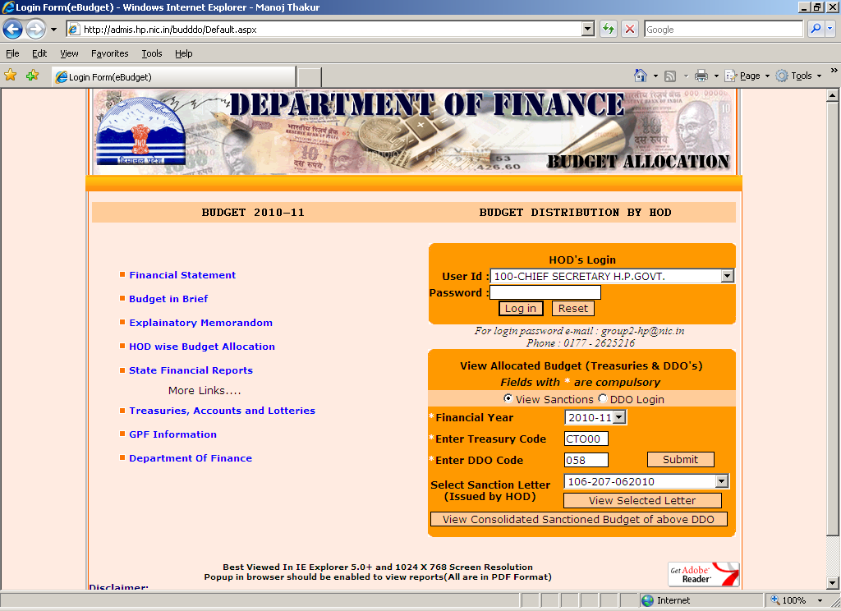
DDO section view after entering Treasury Code & DDO code and pressing Submit Button
Click View Selected Letter to view letter

If you are unable to see the Sanction Letter Check the following:

- Check whether Adobe Acrobat Reader (Application used to view .PDF files) is installed in your system or not? If not installed, then download it from the link provided on the bottom right corner of the page and install it in your computer.
- If Adobe Acrobat Reader is installed then check for the Pop-up blocked message on the top of your web page as shown in the below figure.

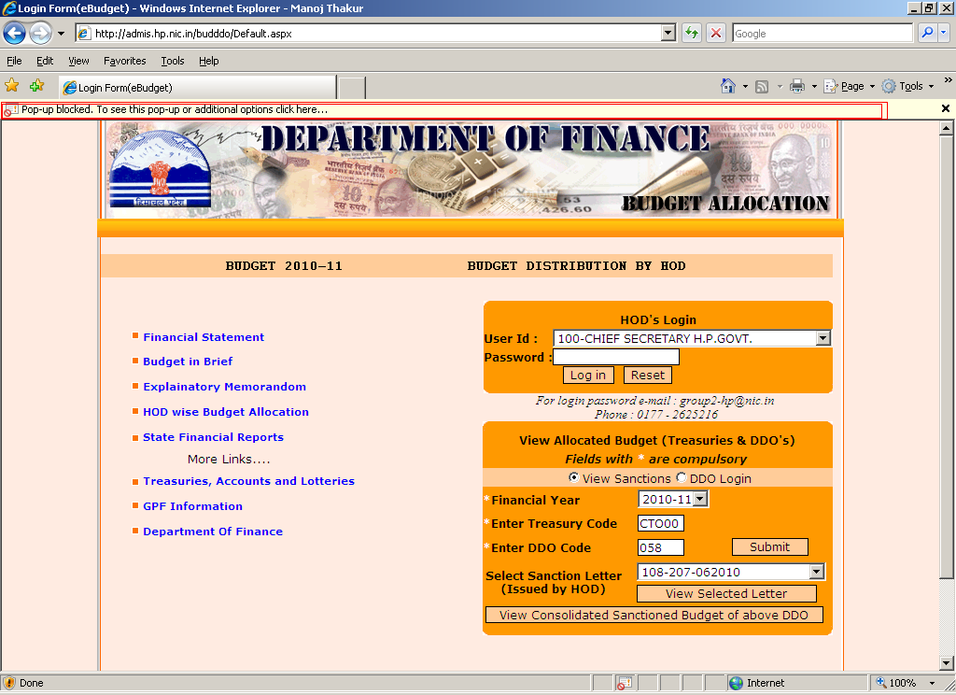

- If you have above error then turn off the popup blocker of your Internet Explorer. Use the steps provided below to turn off the popup blocker in your Internet Explorer.

How to disable popup blocker on Internet Explorer?
Use any of the below mentioned techniques as per your explorer options.

Check the version of Internet Explorer you are using by clicking on Help menu and selecting About Internet Explorer

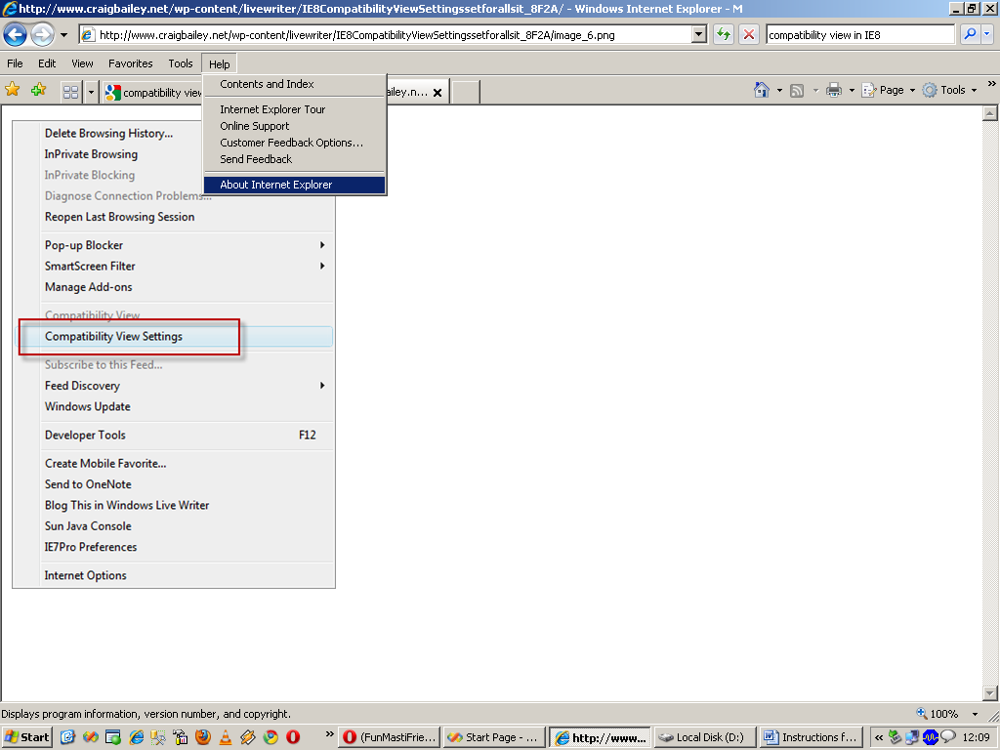

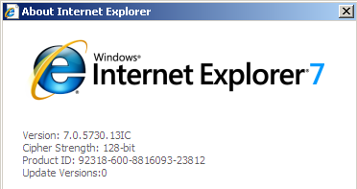

If you are using Internet Explorer 8
- Turn on the compatibility view of the explorer by clicking on Tools Menu and click Compatibility View Settings
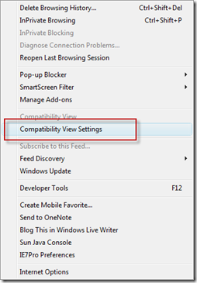
Now turn on Display All websites in compatibility view as shown below.
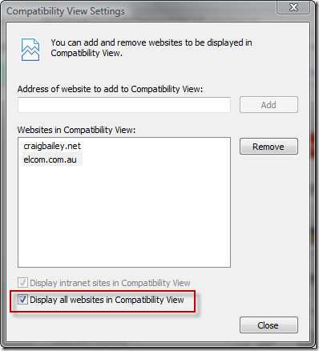

How to disable Internet Explorer 7 popup blocker (Windows XP)
- From the Tools menu, select Internet Options.
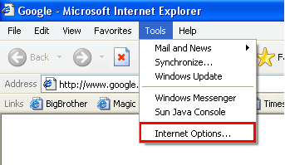
From the Privacy tab, uncheck Turn on Pop-up Blocker and click "OK".
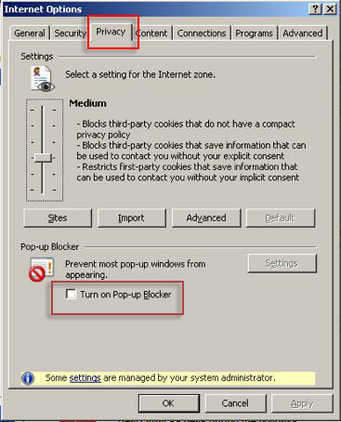

How to disable Internet Explorer 6 popup blocker (Windows XP)
- From the Tools menu, select Internet Options.
- From the Privacy tab, uncheck Block pop-ups.
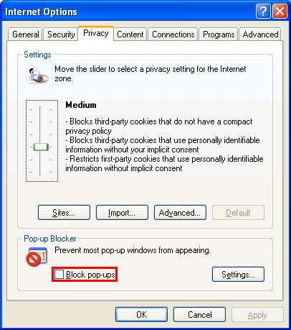

How to disable the Yahoo toolbar popup blocker
- Locate the Popup blocker icon and click the down arrow.
- Uncheck Enable Pop-Up Blocker.
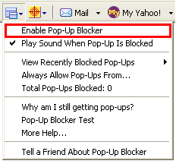

How to disable AOL toolbar popup blocker?
- Locate the Popup blocker icon.
- Click on it until it says Allowed.

How to disable the MSN toolbar popup blocker?
- Locate the Popup blocker icon and click the down arrow.
- Check Allow Pop-ups.
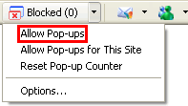

How to disable the Google toolbar popup blocker?
- Click on the Google logo on the Google toolbar and select Options.
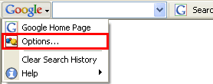
- Uncheck Popup Blocker, and then click OK.
